**Project Management Summary**

**After our project proposal got accepted. We come up with a list of implementations which need to be implemented in to our project. Based on the timelines between the increments and the progress of our lab tutorials, we divided our project into different stories and distributed them across the increments. Further we shared the tasks among our team members between the increments equally.**

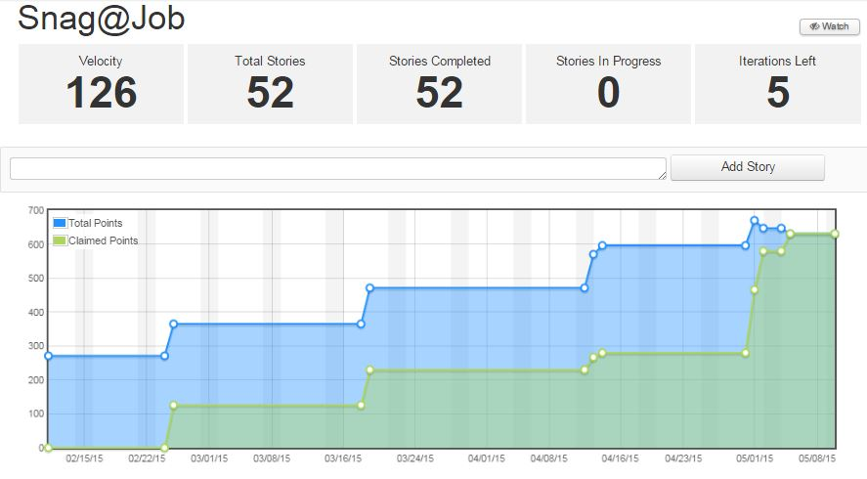**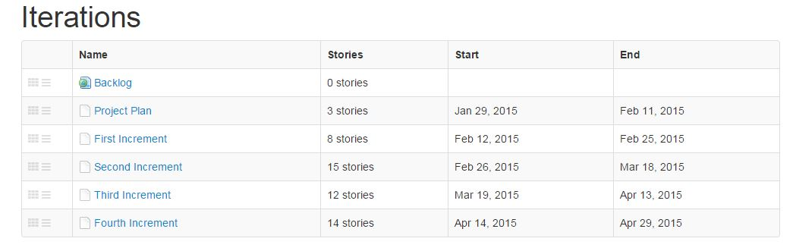Iterations:** Below screenshot clearly gives the detailed information of various increments, Stories per increments and starting and ending dates of the individual increments.

**Project Summary:**

**Project History:**

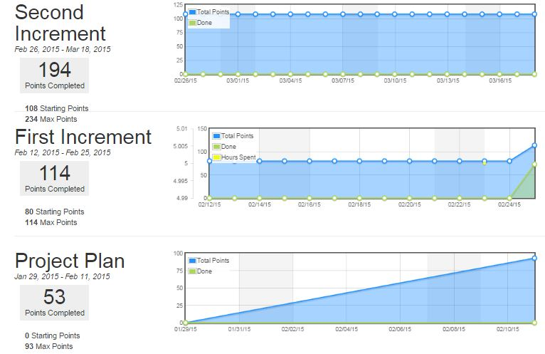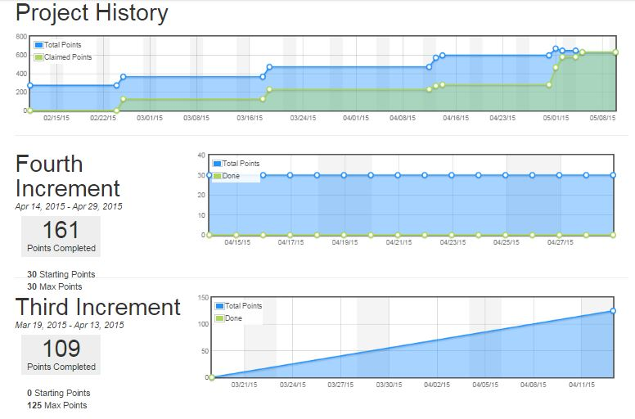

Deployment

## Scrum Do Link

### Summary

<https://www.scrumdo.com/projects/project/snagjob1/summary>

## GitHub Link

### Source Code

<https://github.com/srikarreddy-m/CS551-ASE/tree/src/Project/Snag%40Job/src/>

### Documentation

<https://github.com/srikarreddy-m/CS551-ASE/tree/src/Project/Snag%40Job/documentation>

## Video Link

<https://www.youtube.com/watch?v=zDN0KIQa_UY>